**“TOURISM MANAGEMENT SYSTEM”**

**Mini Project Report 2-A**

Submitted in partial fulfillment of the requirements for

**Third year of Engineering (Computer Engineering)**

**By**

Karishma Apparao Bairi TU3F1920014

Ketki Milind Kulkarni TU3F1920053

Shweta Madhukar Kaware TU3F1920005

Nupoora Deepak Shinde TU3F1920021

Under the Guidance of

**Prof. Kishor Sakure**



**Department of Computer Engineering TERNA ENGINEERING COLLEGE**

Nerul (W), Navi Mumbai 400706

(University of Mumbai)

(2021-2022)

**Internal Approval Sheet**



**TERNA ENGINEERING COLLEGE, NERUL**

**Department of Computer Engineering**

Academic Year 2021-22

**CERTIFICATE**

This is to certify that the project entitled **“TOURISM MANAGEMENT SYSTEM”** is a bonafide work of

Karishma Apparao Bairi TU3F1920014

Ketki Milind Kulkarni TU3F1920053

Shweta Madhukar Kaware TU3F1920005

Nupoora Deepak Shinde TU3F1920021

submitted to the University of Mumbai in partial fulfilment of the requirement

for the Third year of Engineering. (Computer Engineering).

**Guide Project Convener Head of Department Principal**

**Approval Sheet**

Project Report Approval

This Project Report – A entitled **“TOURISM MANAGEMENT SYSTEM”** by following students is approved for T.E. in "Computer Engineering".

***Submitted by:***

Karishma Apparao Bairi TU3F1920014

Ketki Milind Kulkarni TU3F1920053

Shweta Madhukar Kaware TU3F1920005

Nupoora Deepak Shinde TU3F1920021

Examiner’s Name & Signature:

1. ______________________
2. ______________________

Date:

Place:

**DECLARATION**

We declare that this written submission represents our proposal in our own words and where others ideas or words have not been included, we have suitably mentioned and referenced the original sources. We also declare that we have stuck to all principles of academic uprightness and integrity and have not misrepresented or created or falsified any idea/data/fact/source in our submission. We understand that any infraction of the above will be cause for disciplinary action by the Institute and can also call up penal action from the sources which have thus not been properly mentioned or from whom proper permission has not been taken when needed.

Karishma Apparao Bairi TU3F1920014 ---------------------------

Ketki Milind Kulkarni TU3F1920053 ---------------------------

Shweta Madhukar Kaware TU3F1920005 ---------------------------

Nupoora Deepak Shinde TU3F1920021 ---------------------------

Date:

Place:

**ACKNOWLEDGEMENT**

Project is never complete without the guidance of those expert who have already traded this past before, and hence become master of it and as a result, our leader. So, we would like to take this opportunity to take all those individuals who have helped us in visualizing this project.

We express our extensive gratitude to our project guide Mr. Kishor Sakure for providing timely assistant to our query and guidance that he gave owing to his experience in this field for past many years. He had indeed been a leading light for us in this journey.

We would also take this opportunity to thank our project coordinator Mrs. Mohini Misale for her guidance in selecting this project and also for providing us all this details on proper presentation of this project.

We extend our sincere appreciation to all our Professor from TERNA ENGINEERING COLLEGE for their valuable insight and tip during the designing of the project. Their contributions have been valuable in so many ways that we find it is difficult to acknowledge them individually.

We are also obliged to our HOD Mrs. Archana Mire for extending her help directly and indirectly through various channel in our project work.

We take the privilege to express our sincere thanks to Principal Dr. L. K. Ragha for providing encouragement and much support throughout our work.

Karishma Apparao Bairi TU3F1920014

Ketki Milind Kulkarni TU3F1920053

Shweta Madhukar Kaware TU3F1920005

Nupoora Deepak Shinde TU3F1920021

**Table of contents**

|  |  |  |
| --- | --- | --- |
| **Sr No.** | **Chapter** | **Page No.** |
| **1** | **Introduction** | **8** |
| **2** | **Literature Review** | **11** |
| **3** | **Methodology** | **13** |
| **4** | **Hardware & Software Requirements** | **17** |
| **5** | **Implementation** | **20** |
| **6** | **Results and Discussion** | **29** |
| **7** | **Conclusion** | **37** |
| **8** | **References** | **38** |

**ABSTRACT**

Kashkenu Travels is a web-based application that enables travellers check for travel package availableness, book a train or flight ticket, which also includes stay at hotels. The aim of this Travel website is to automate the existing manual system by the assistance of computerized equipments and full-fledged computer software, fulfilling the necessities, so that their valuable data information may be stored for a extended amount with straightforward accessing and manipulation of an equivalent. The organization can maintain computerised records without redundant entries. Tools like HTML, CSS, PHP were used to develop Tourism Management System.

**CHAPTER 1: INTRODUCTION**

Kashkenu Travels is an online system that utilizes the benefits of the internet to supply travel services starting from booking travel/ holiday packages which also includes stays at hotels to mode of travel i.e. either Train or Flight for patrons from their homes. We provide a simple straightforward internet interface to make the travel request and services booking method easy. All users have access to an online portal to book their travel with few mouse clicks. No formal data is required for the user to use this method. Therefore by this all it proves that it's user-friendly. Customers won't need to go all the way to the travel company, wait in long queues and await the travel agent to tell them about the available travel packages and their fares. Usually if the passengers desire a pick and drop services from the bus stop to the hotel, the agent might charge exorbitant fees for all the transportations which will be provided during the passengers stay in the desired destination. Sometimes, the transportation provided in such cases isn't the one that was promised, and generally it's merely not offered, that may be a terribly frustrating situation.

As the result of the survey conducted, due to the intense number of human traffic, purchasing any travel ticket manually is not merely a ten or twenty minutes task, but in fact, it can even take upto an hour or two especially during the peak seasons. The best option hence is to book everything online: travel ticket, hotel and the further needed transportations. The two main advantages of travellers are convenience and a more secure way of travelling. Under the traditional system, most travellers have to carry physical tickets given to them from the counter at all time of travelling. With e-ticketing, all associated information will be stored digitally in a central database and therefore there are no chances of the traveller losing them or having them stolen.

**1.1: AIM AND OBJECTIVE OF THE PROJECT**

**The main objective of our Project Tourism Management System is management of packages, travel mode, booking dates, customer verification and payment. The project is totally built at user end and therefore everyone has access but the logins can only be accessed by the registered user. The purpose of the project is to build website which reduces the manual work for managing the Travel, Tour and Customer.**

**1.2: SCOPE OF THE PROJECT**

Tourism Management System is an integrated website developed for helping customers explore different places with effective packages. The main aim of this project is to manage their

customers. It makes all operation for the customer easy and accurate.

The standalone platform makes this tourism management system easy by handing customers requests located at different parts of the various cities. Different modules have been incorporated in this project to handle different parts and sector of the tourism management system.

**1.3: ORGANIZATION OF THE REPORT**

Chapter 1 contains brief introduction of our project with aim, objective and scope of the project.

Chapter 2 contains Literature Survey. In this chapter, we have studied and reviewed the previous work done on the topics related to our project. We have included different papers published by their respective authors.

Chapter 3 Methodology deals with the Block Diagram, Explanation of the Block Diagram, Modules of System and System Design Details.

Chapter 4 includes Hardware and Software Requirements of the project.

Chapter 5 includes the code of the project.

Chapter 6 contains screenshots of the output.

Chapter 7 is the conclusion of the project.

Lasly, it has list of references.

**CHAPTER 2: LITERATURE REVIEW**

|  |  |  |  |
| --- | --- | --- | --- |
| **Year** | **Author Name** | **Paper Name** | **Description** |
| 2010 | Mirjha Gupta | My Web application | Tourists were satisfied with cultural attractions and amenities of but mainly they were satisfied with the cultural attractions. Very significant number of tourist had a good image and they were keen about revisiting in future & recommending their friends and relatives. |
| 2012 | Bennet Mathew | Web Application Research | The main purpose was to help tourism companies to manage customer and hotels etc. The system could also be used for both professional and business trips. |
| 2014 | Prof. Shweta K. Rao | Tours and Travels Designing | The analysis took into account the travelling group composition. The results showed that, for the total tourist sample, overall satisfaction had the biggest influence on the decision of whether to revisit a destination. |
| 2016 | David Simmon | Book of Exploration | This Tourism Management System was developed in order to lessen the manual work. This online Tourism Management system helped customers to book packages easily online. |
| 2018 | Joan Henderson | Study on Online Websites | This Tourism Management system was used to enhance the accuracy of bookings. It was used to book tickets without any discrepancies by saving customers information. |

**2.2: EXPLANATION OF LITERATURE PAPERS**

**Paper 1 : My Web Application By Mirjha Gupta**

In this paper author says that tourists were satisfied with cultural attractions and amenities of but mainly they were satisfied with the cultural attractions. Very significant number of tourist had a good image and they were keen about revisiting in future & recommending their friends and relatives.

**Paper 2 : Web Application Research By Bennet Mathew**

In this paper the author says that the main purpose was to help tourism companies to manage customer and hotels etc. The system could also be used for both professional and business trips.

**Paper 3 : Tours and Travels Designing by Prof. Shweta K. Rao**

In this paper the author says that the analysis took into account the travelling group composition. The results showed that, for the total tourist sample, overall satisfaction had the biggest influence on the decision of whether to revisit a destination.

**Paper 4** **: Book of Exploration By David Summon**

In this paper the author says that this Tourism Management System was developed in order to leseen the manual work. This online Tourism Management system helped customers to book packages easily online.

**Paper 5** **: Study on Online Websites by Joan Henderson**

In this paper the author says that this Tourism Management system was used to enhance the accuracy of bookings. It was used to book tickets without any discrepancies by saving customers information.

**CHAPTER 3: METHODOLOGY**

This system is named as Tourism Management System. This is designed especially for customers who want to travel hassle free and hence the website is developed in a very well manner. This system has the capability to take the details of the customers from themselves. Then the customer has to search for a package of his choice or which is convenient to him. Further, he has to opt for any one mode of travel i.e. either Train or Flight. Then he has to complete his reservation by making payment of that particular Travel Package. He will receive an e-mail which will include the receipt of the payment.

The great thing is that it will be simply utilized by the customers from different locations and is powered with extremely customisable strong options to fulfill each demand of our customer, be it managing the Registration to keep customer’s details if new to the website and Login for existing Customers, managing different packages of tours, managing the mode of travel i.e. Train or Flight, managing payment from customers to confirm their reservation or managing any knowledge that’s necessary for your customer, no matter the place and time, we have got it all covered. Tools like HTML, CSS, PHP were used for developing the website.

**3.1: BLOCK DIAGRAM:**

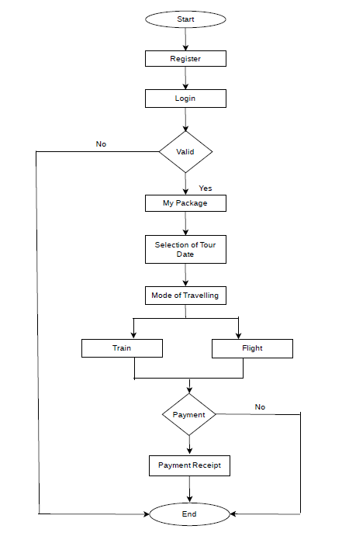

**3.2: EXPLANATION OF THE BLOCK DIAGRAM:**

This block diagram describes the working of Tourism Management System. It is an connecting link between the user and database. User interacts with the system and database stores information regarding the customer and its bill. When you start the web application, it asks you to Register if you haven’t already or you can simply Login if you are an existing user. On the successful Register or Login, you can go to My Packages to explore the various Travel Packages. Then after selecting your desired Package, you can select the date of the travel from 3-4 options as per your convenience. Further, you are supposed to select the Mode of your travel i.e. either Train or Flight. For confirming your reservation, you have to make the payment as displayed for that particular package. After the successful payment, you will receive an e-mail on registered e-mail id, which will include the payment receipt with all the details.

**3.3: MODULES OF SYSTEM:**

**Register/Login Module:**

Used for managing Registration to keep customer’s details if new to the website and Login for existing Customers.

**Package Module:**

Used for managing different packages of tours.

**Reservation Module:**

Used for managing the mode of travel i.e. Train or Flight.

**Payment Module:**

Used for receiving payment from customers to confirm their reservation.

**Management Module:** Used for managing the travel/tour details.

**3.4: SYSTEM DESIGN:**

Now, this system is designed in such a way that it takes fewer resources to work properly. It has its own sort of minimum requirements that we need to take care of :

The system needs a minimum of 2 GB of RAM to run all the features smooth and sudden.

It needs a minimum 1.3 GHz processor to rum smooth as less than that may create problems.

For security Antivirus is recommended.

The system has modules to store every entity in a proper manner and needed to place in a proper manner so we need to have a proper design for that we put all of it in block diagram of this website.

**Modes one can opt for is:**

**Card or UPI :**

This is the most common and most popular way of payment. Due to advantages of need not to carry cash, it gained popularity. You can use UPI or any card for payment of your package.

**CHAPTER 4: HARDWARE & SOFTWARE REQUIREMENTS**

**4.1: HARDWARE REQUIREMENTS:**

**Processor:** Celtron 500MHZ or any PENTIUM Processor

**RAM:** 2 GB or Above

**Hard Disk Capacity:** Minimum Requirement is 80 GB

**Display Type:** Standard VGA or SVGA card

**4.2: SOFTWARE REQUIREMENTS:**

**Operating System:** Windows 95 or 98, XP

**Frontend:** HTML, CSS

**4.3: FRONTEND AND BACKEND IN THE PROJECT:**

**HTML, CSS - Frontend**

**PHP - Backend**

HTML, CSS is used in frontend and PHP is used in backend.

Frontend- It is the GUI page which is displayed which consists of buttons, labels, etc.

Backend- It is the place where the data is stored.

So in our project we have created frontend using HTML, CSS and Backend using PHP.

**4.3.1: Advantages of HTML and CSS:**

HTML which stands for Hypertext Markup Language is thepredominant markup languages for web pages. HTML is the basic building block of WebPages. This is written with HTML in the form of HTML elements consisting of tags, enclosed in anglebrackets (like <html>), within the web page content. HTML tags normally come in pairs like <hland </hl>. The first tag in a pair is the start tag, the second tag is the end tag (they are also calledopening and closing tags). In between these tags web designers can add text, tables, images, etc.the purpose of a web browser is to read HTML documents and compose them into visual oraudible web pages. The browser does not display the HTML tags, but uses the tag to interpret thecontent of the page.HTML allows images and objects to be embedded and can be used to create interactive forms. Itprovides a means to create structured documents by denoting structural semantics for text such asheadings, paragraphs, lists, links, quotes and other items. It can embed scripts in languages suchas JavaScript which affect the behavior of HTML WebPages. Web browsers can also refer toCascading Style Sheets (CSS) to define the appearance and layout of text and other material. TheW3C , maintainer of both the HTML and the CSS standards, encourages the use of CSS overexplicitly presentational HTML markup.

**4.3.2: Advantages of PHP:**

PHP is a general-purpose scripting language originally designed for web development to produce dynamic web pages. For this purpose, PHP code is embedded into this system’s pages interpreted by a web server with a PHP processor module, which generates the web pagedocument. PHP can be deployed on most web servers and as a standalone interpreter, on almost every operating system and platform free of charge. A competitor to Microsoft’s Active Server Pages (ASP) server side script engine and similar languages, PHP is installed on more than 20 million websites and 1 million web servers. PHP was originally created by Rasmus Lerdorf in 1995. The main implementation of PHP Group and serves as the de facto standard for PHP as there is no formal specifications. PHP is free software released under the PHP license.

**CHAPTER 5: IMPLEMENTATION**

**5.1: OVERVIEW OF RESULTS:**

First of all, the result shows Home Page of our Tourism Management System. It consists of the following buttons which are Register/Login, Home Page, About Us, Contact info and Package. After this, on clicking Package Button we can see the packages divided into different categories based on their types. Every Package has its individual description inside it. Then, on clicking the Book Now button of the desired package one can select dates of the tour from 4-5 options as per his convenience. Further, one should select the Mode of Travel i.e. Train or Flight. Then the payment of that package should be completed which also includes verification of customers. After confirming the reservation, the receipt of the payment will be mailed to the registered e-mail address of the same.

**5.2: CODE:**

**Login-**

<html>

<body bgcolor="pink">

<h1>Registered User Login</h1>

<font size=5>

Enter Username: <input type="text" name="txt" maxlength="20"/><br><br>

Enter Password: <input type="password" name="pass"/><br><br>

<button type="button"><a href="index.html">Login</a></button><br>

</font>

</body>

</html>

**Registration-**

<!DOCTYPE html>

<html>

<head>

<title><h1>Registration Page</h1></title>

</head>

<body bgcolor="pink">

<div class="container">

<div class="row col-md-6 col-md-offset-3">

<div class="panel panel-primary">

<div class="panel-heading text-center">

<h1>Registration Form</h1>

</div>

<div class="panel-body">

<form action="connect.php" method="post">

<div class="form-group">

<label for="firstName"><b>First Name</label></b>

<input

type="text"

class="form-control"

id="firstName"

name="firstName"

/>

</div>

<br>

<div class="form-group">

<label for="lastName"><b>Last Name</label></b>

<input

type="text"

class="form-control"

id="lastName"

name="lastName"

/>

</div>

<br>

<div class="form-group">

<label for="gender"><b>Gender</label></b>

<div>

<label for="male" class="radio-inline"

><input

type="radio"

name="gender"

value="m"

id="male"

/><b>Male</b></label

>

<label for="female" class="radio-inline"

><input

type="radio"

name="gender"

value="f"

id="female"

/><b>Female</b></label

>

<label for="others" class="radio-inline"

><input

type="radio"

name="gender"

value="o"

id="others"

/><b>Others</b></label

>

</div>

<br>

</div>

<div class="form-group">

<label for="email"><b>Email</label>

<input

type="text"

class="form-control"

id="email"

name="email"

/>

</div>

<br>

<div class="form-group">

<label for="password"><b>Password</label></b>

<input

type="password"

class="form-control"

id="password"

name="password"

/>

</div>

<br>

<div class="form-group">

<label for="number"><b>Phone Number</label></b>

<input

type="number"

class="form-control"

id="number"

name="number"

/>

</div>

</form>

</div>

<button type="button" style="color: rgb(5, 4, 10);"><a href="index.html">

Submit</a></button>

</div>

</div>

</div>

</div>

</body>

</html>

**My Package-**

<!DOCTYPE html>

<html>

<head>

<style>

table {

font-family: arial, sans-serif;

border-collapse: collapse;

width: 100%;

}

td, th {

border: 2px solid #110e0e;

text-align: left;

padding: 8px;

}

tr:nth-child(even) {

background-color: #dddddd;

}

</style>

</head>

<body style="background-color: darkgrey;">

<h2 style="color: rgb(37, 27, 78);">OUR PACKAGES...</h2>

<table>

<tr>

<th><b>DESTINATION</b></th>

<th><b>DESCRIPTION</b> (Please note that we have tie-ups with hotels at respective destinations and

prices include ticket and hotel booking per person)</th>

</tr>

<tr>

<td><figure>

<img src="kerla.png" width="100" height="100"><figcaption><i>KERLA</i></figcaption>

</figure></td>

<td><b>Places to visit:</b>Alleppey, Wayanad, Kochi, Munnar, Kumarakom, Kollam <br><b>Cities:</b>6

<b>Days:</b>11 <b>Best Period to Visit:</b>October to March <b>Price:</b>Rs. 17,000 <br>

<button type="button" style="color: rgb(1, 2, 0); background-color: rgb(116, 199, 49);"><a href="reservation1.html">

BOOK NOW</a></button></td>

</tr>

<tr>

<td><figure>

<img src="rajasthan.png" width="100" height="100"><figcaption><i>RAJASTHAN</i></figcaption>

</figure></td>

<td><b>Places to visit:</b>Jaipur, Jodhpur, Udaypur, Mount Abu, Ajmer <br><b>Cities:</b>6

<b>Days:</b>11 <b>Best Period to Visit:</b>October to March <b>Price:</b>Rs. 15,000 <br>

<button type="button" style="color: rgb(1, 2, 0); background-color: rgb(116, 199, 49);"><a href="reservation2.html">

BOOK NOW</a></button></td>

</tr>

<tr>

<td><figure>

<img src="gujrat.png" width="100" height="100"><figcaption><i>GUJRAT</i></figcaption>

</figure></td>

<td><b>Places to Visit:</b>Ahemdabad, Kutch, Gir National Park, Somnath, Statue of Unity, Vadodara,

Dwarka, Saputara, Junagadh<br><b>Cities:</b>7 <b>Days:</b>13 <b>Best Period to Visit:</b>July to March

<b>Price:</b>Rs. 13,000 <br>

<button type="button" style="color: rgb(1, 2, 0); background-color: rgb(116, 199, 49);"><a href="reservation3.html">

BOOK NOW</a></button></td>

</tr>

<tr>

<td><figure>

<img src="mp1.jpg" width="100" height="100"><figcaption><i>MADHYA PRADESH</i></figcaption>

</figure></td>

<td><b>Places to Visit:</b>Khajuraho, Bhedaghat, Pachmarhi, Gwalior, Bandhavgarh National Park,

Kanha National Park, Sanchi, Indor, Ujjain <br><b>Cities:</b>7 <b>Days:</b>13 <b>Best Period to Visit:</b>November to

March <b>Price:</b>Rs. 15,000 <br>

<button type="button" style="color: rgb(1, 2, 0); background-color: rgb(116, 199, 49);"><a href="reservation4.html">

BOOK NOW</a></button></td>

</tr>

<tr>

<td><figure>

<img src="daman.png" width="100" height="100"><figcaption><i>DAMAN</i></figcaption>

</figure></td>

<td><b>Places to visit:</b>Devka Beach, Moti Daman Fort, Lighthouse, Mirasol Lake Garden, Nani Daman Fort<br> <b>City:</b>1

<b>Days:</b>5 <b>Best Period to visit:</b>October to March <b>Price:</b>Rs.10,000

<br><button type="button" style="color: rgb(1, 2, 0); background-color: rgb(116, 199, 49);"><a href="reservation5.html">

BOOK NOW</a></button></td>

</tr>

<tr>

<td><figure>

<img src="goa1.jpg" width="100" height="100"><figcaption><i>GOA</i></figcaption>

</figure></td>

<td><b>Places to visit:</b>Palolem Beach, Colva Beach, Dudhsagar Falls, The Church of Our Lady of the

Immaculate Conception, Braganza House, Fort Aguada<br><b>Cities:</b>2 <b>Days:</b>6 <b>Best Period to Visit:</b>December to March <b>Price:</b>Rs. 10,000

<br><button type="button" style="color: rgb(1, 2, 0); background-color: rgb(116, 199, 49);"><a href="reservation6.html">

BOOK NOW</a></button></td>

</tr>

</table>

</body>

</html>

**CHAPTER 6: RESULTS AND DISCUSSION**

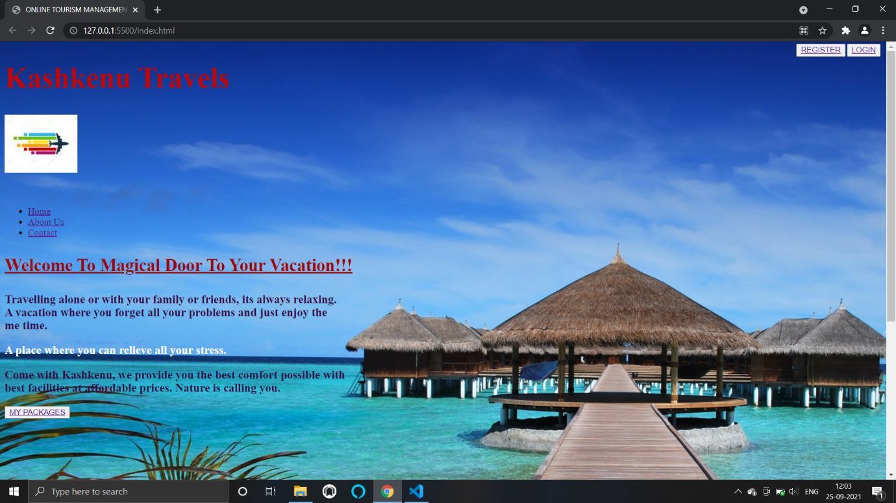

**Figure 6.1: Home Page**

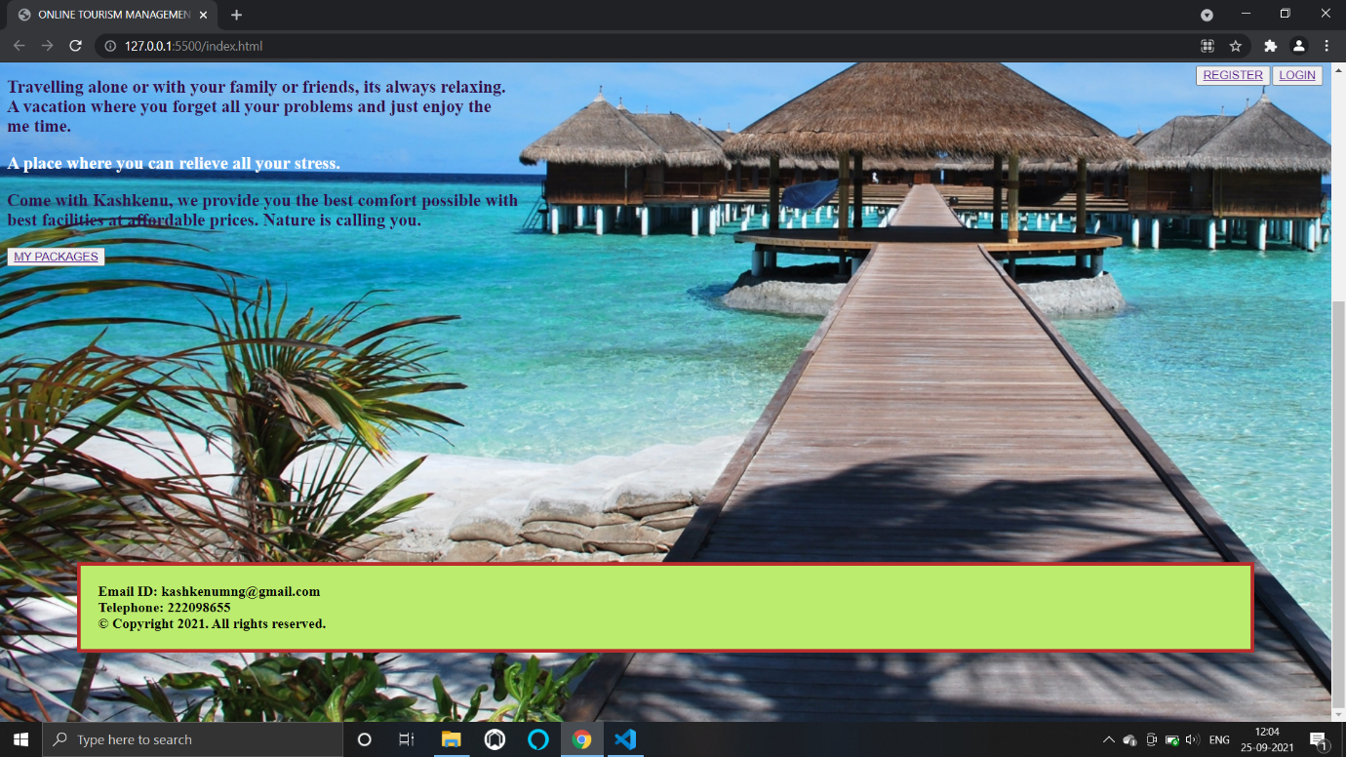

**Figure 6.2: Home Page**

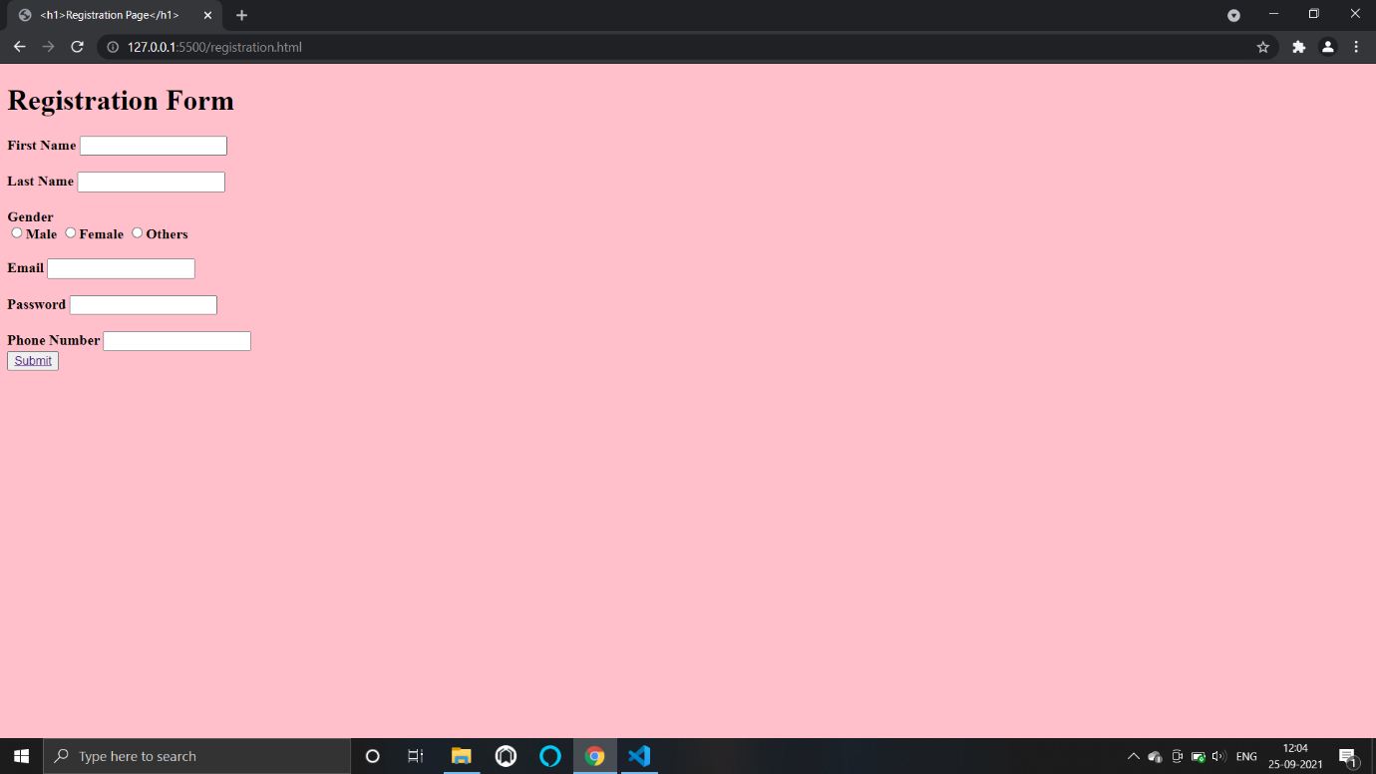

**Figure 6.3: Registration Form**

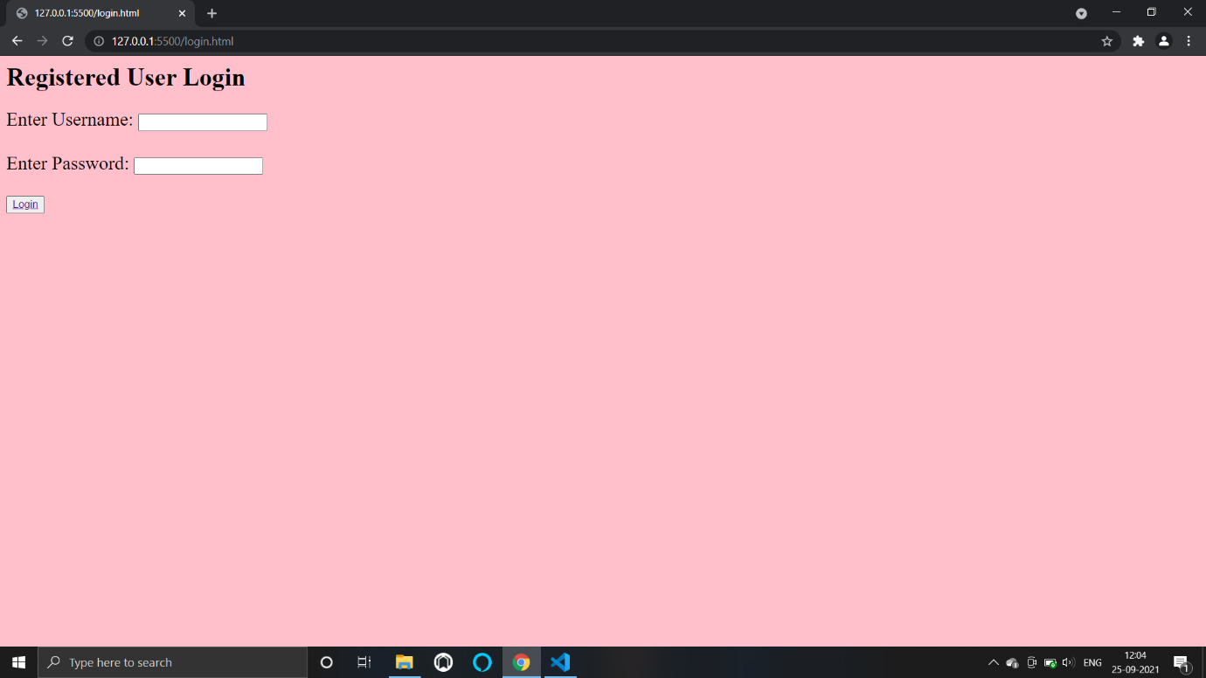

**Figure 6.4: Login**

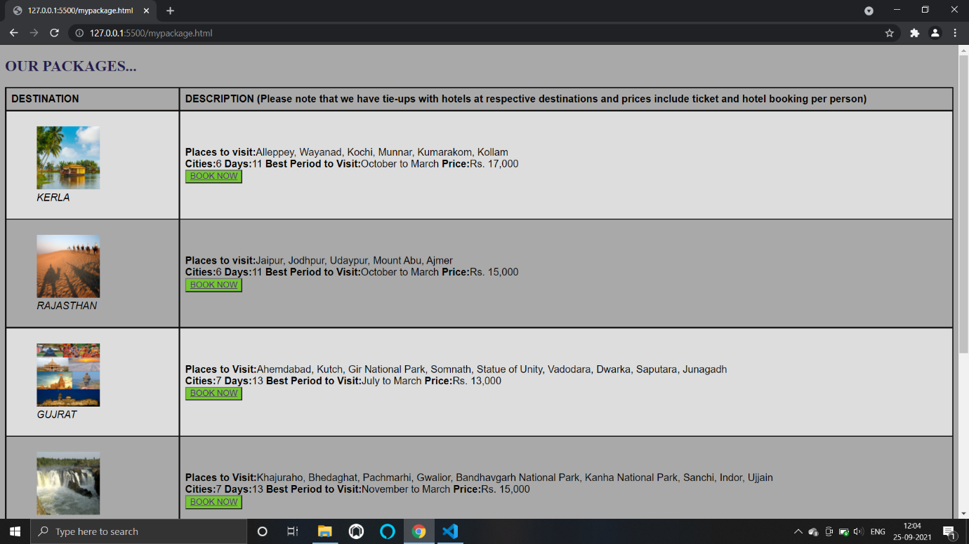

**Figure 6.5: Packages**

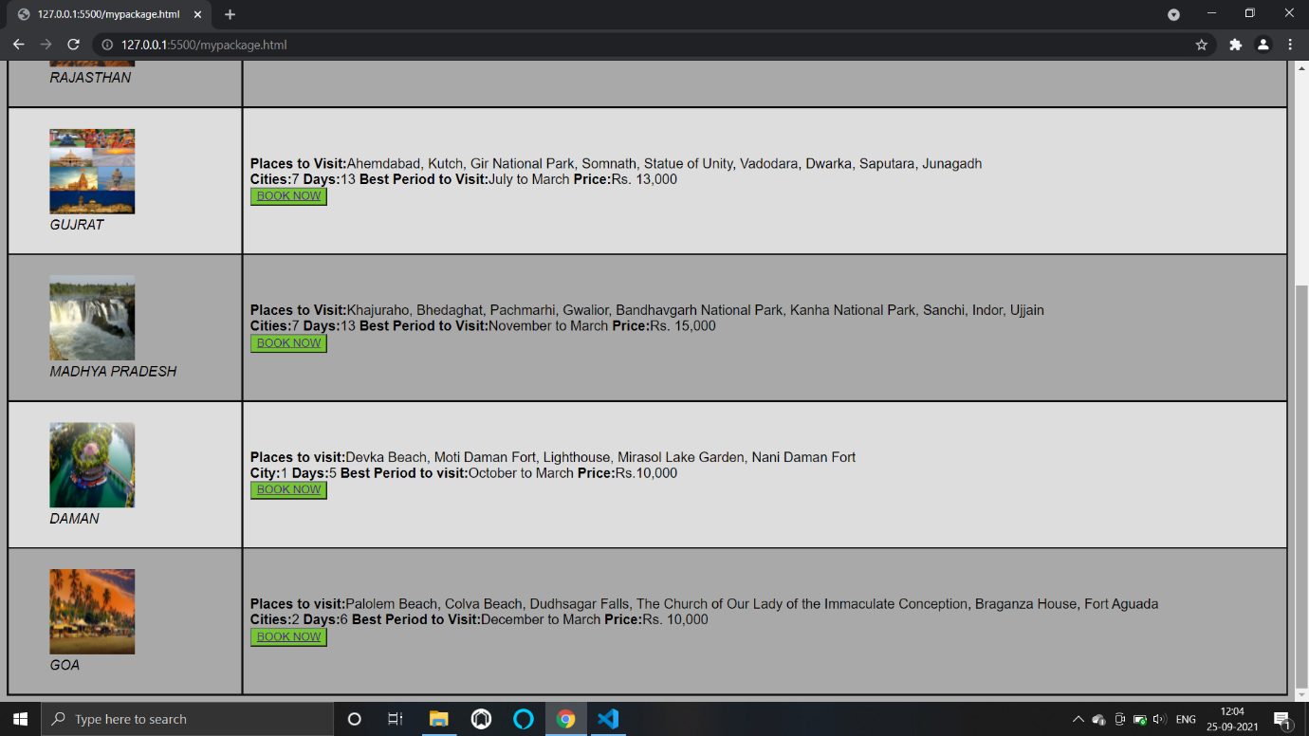

**Figure 6.6: Packages**

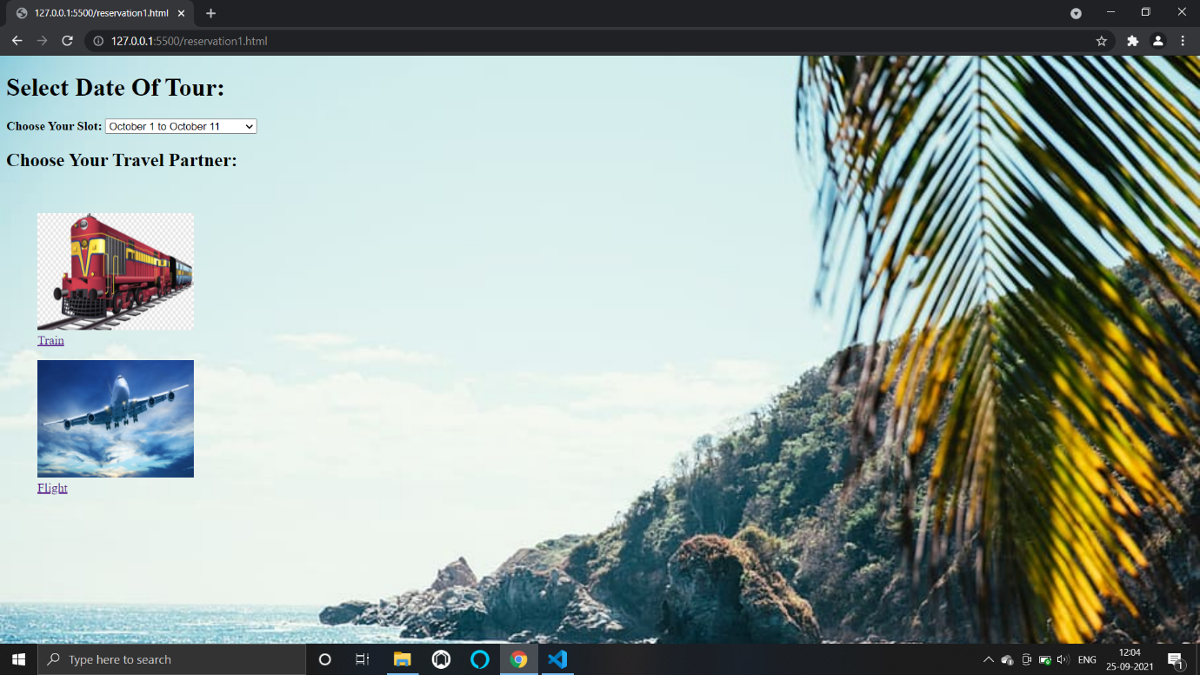

**Figure 6.7: Selection of Dates & Mode of Travel**

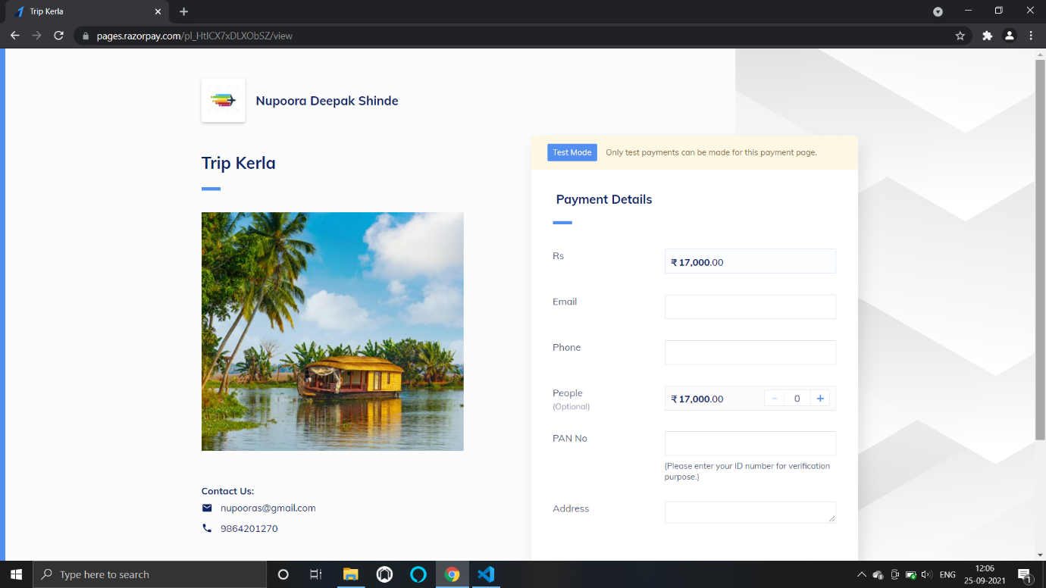

**Figure 6.8: Payment Procedure**

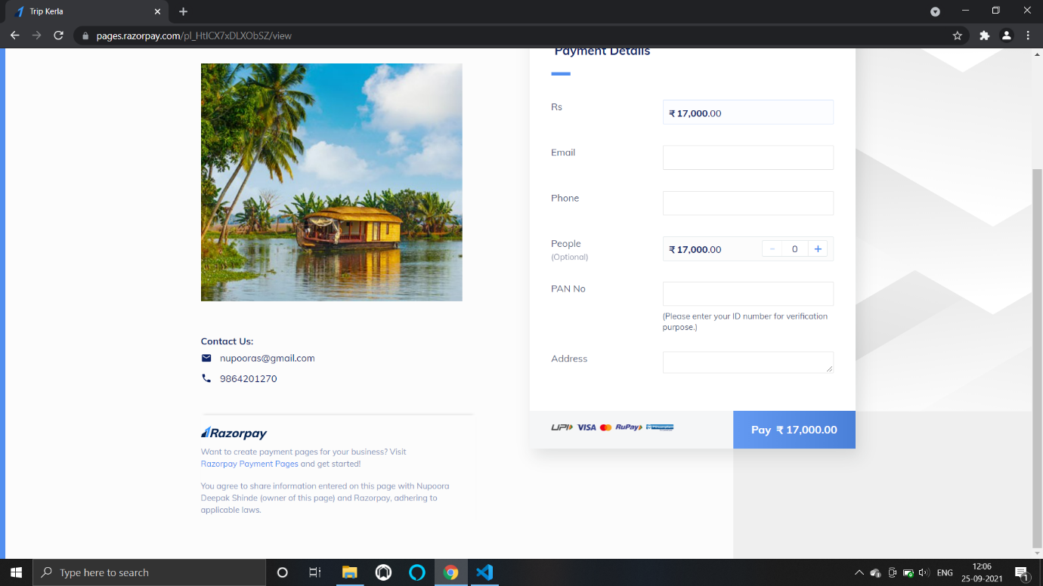

**Figure 6.9: Payment Procedure**

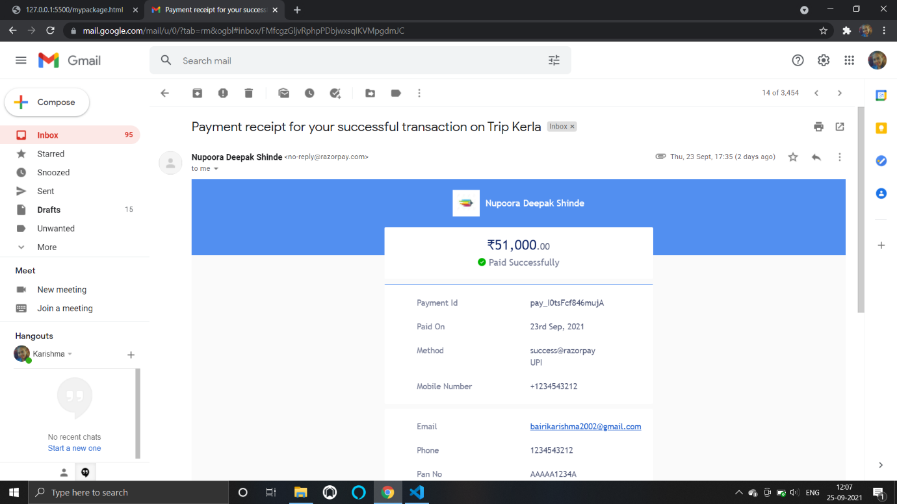

**Figure 6.10: E-Mail of Payment Receipt**

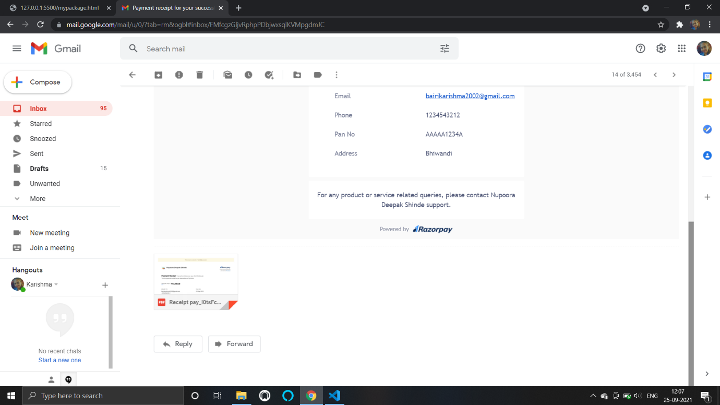

**Figure 6.11: E-Mail of Payment Receipt**

**CHAPTER 7: CONCLUSION**

After we have completed the project we are sure the problems in the existing website would overcome. The "Tourism Management System" process made computerized records to reduce human errors and to increase the efficiency. The main focus of this project is to lessen human efforts and to get the correct information about a customer alongwith proper booking and payment details.

➢ This website can be simply utilized by the customers and is powered with extremely customisable strong options to fulfill each demand of our customers.

➢ It also verifies customer id and generates payment receipt which is mailed to the customer's registered mail id for the confirmation of payment.

**REFERENCES**

1. **Mirjha Gupta, My Web application, 2010.**
2. **Bennet Mathew, Web Application Research, 2012.**
3. **Prof. Shweta K. Rao, Tours and Travels Designing, 2014.**
4. **David Simmon, Book of Exploration, 2016.**
5. **Joan Henderson, Study on Online Websites, 2018.**